PayPal AI Hackathon
Working Product Concept
AI Agent for the End-to-End Payment Lifecycle
Working document for team review — not the final hackathon submission

1. Executive Summary
The current idea is to build an AI agent that sits on top of PayPal's existing payment infrastructure. The user tells the agent what they want to achieve, such as getting paid for completed work. The agent understands the request, creates and manages the required PayPal workflow, monitors the transaction, and takes follow-up actions when needed.
The important point is that we are not trying to replace or change PayPal's backend. We use PayPal's existing APIs, Agent Toolkit and MCP tools as the transaction layer, while AI handles the understanding, planning, decision-making, monitoring and follow-up.

2. Working Product Statement
Build an AI agent that understands a user's payment goal and manages the payment lifecycle through PayPal — from creating and sending an invoice to monitoring payment status and handling common follow-up situations.
This is our current working statement. It should be reviewed by all three team members before we lock the final direction.

3. Why This Direction
- PayPal already provides the core payment infrastructure.
- PayPal provides tools for invoices, payments, transactions, refunds, disputes, shipment tracking and subscriptions.
- AI can make these tools easier to use by turning many separate actions into one natural-language workflow.
- The agent can continue working after the first action instead of stopping after a single API call.
- Negative customer feedback can help us identify where the agent should add extra support, without trying to change PayPal's backend.
- The concept is strongly connected to the hackathon's AI + PayPal + agentic commerce direction.

4. Product Idea in Simple Terms
Imagine a freelancer has completed a project and says:
"I completed the project for Acme. Get me paid $2,500."
Instead of asking the user to manually open PayPal, create an invoice, enter customer details, send the invoice, check whether it was paid, and remember to follow up, the agent manages the workflow.

5. High-Level User Journey
Step | Stage | What Happens
1 | User gives an outcome | "Get me paid $2,500 by Acme."
2 | AI understands the request | Extract customer, amount, service, due date and other required information.
3 | AI creates a plan | Decide which PayPal tools are needed and in what order.
4 | Create the PayPal invoice | Call create_invoice.
5 | Send the invoice | Call send_invoice.
6 | Monitor the payment | Use list_invoices / get_invoice and transaction information.
7 | Reason about the current state | Paid, pending, overdue, refunded, disputed, etc.
8 | Take the next action | For example, send a reminder or start a permitted resolution flow.
9 | Update the user | Explain what happened and what the agent did.

6. High-Level Architecture
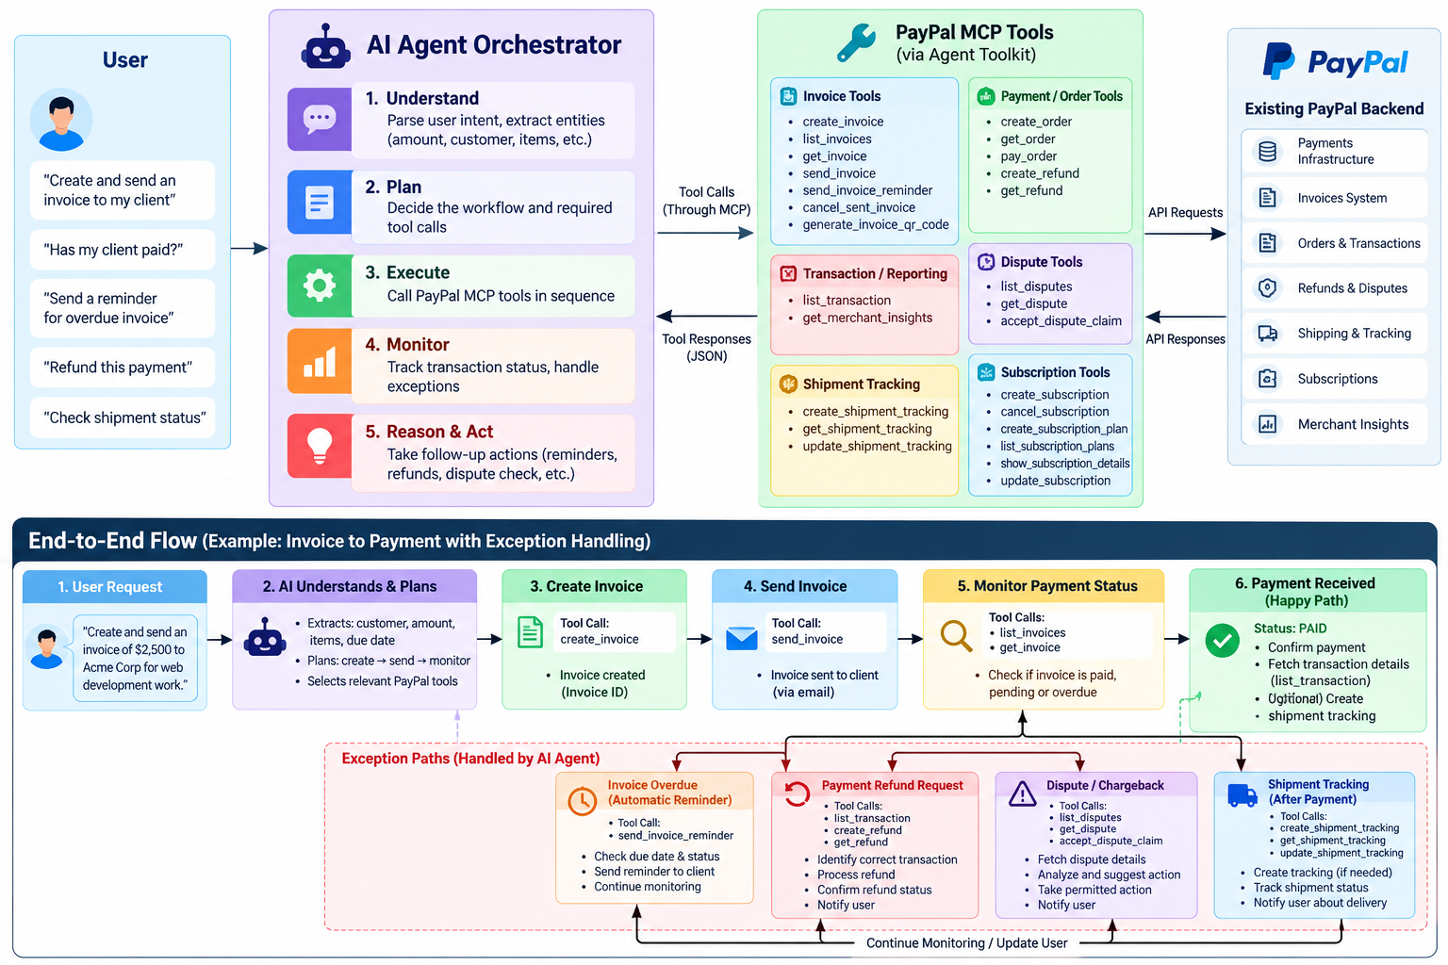
Current high-level flow: User → AI Agent → PayPal MCP/Agent Tools → PayPal infrastructure

7. Main Components
Component | Role
User | Gives the agent a goal in normal language.
AI Agent / Orchestrator | Understands intent, builds the workflow, chooses tools, checks results and decides the next action.
Workflow / State | Keeps track of where the payment currently is, such as invoice created, sent, paid or overdue.
PayPal MCP / Agent Tools | Provides the actions the agent can call.
PayPal Backend | Performs the actual payment, invoice, refund, dispute and other financial operations.
Event / Monitoring Layer | Lets the system react when payment or transaction status changes, instead of treating the interaction as one request and one response.

8. PayPal Tools We Expect to Use
Tool Group | Tools
Invoice | create_invoice, list_invoices, get_invoice, send_invoice, send_invoice_reminder
Payment / Order | create_order, get_order, pay_order, create_refund, get_refund
Transaction / Reporting | list_transaction, get_merchant_insights
Disputes | list_disputes, get_dispute, accept_dispute_claim
Shipment Tracking | create_shipment_tracking, get_shipment_tracking, update_shipment_tracking
Subscriptions | create_subscription, cancel_subscription, create_subscription_plan, list_subscription_plans, show_subscription_details, show_subscription_plan_details, update_subscription

9. Where AI Is Actually Used
AI Capability | Purpose
Understand | Convert a natural-language request into structured payment intent.
Plan | Choose the right PayPal workflow and tool sequence.
Decide | Choose the next action based on transaction state and user intent.
Explain | Explain payment status, delays, reminders or other events in simple language.
Monitor | Track the lifecycle instead of ending after the first tool call.
Act | Call PayPal tools to create, send, refund, remind, track or resolve.
Handle exceptions | When something goes wrong, identify the situation and choose the appropriate next step.

10. Happy Path + Pain Point Strategy
We are not building a product only to fix negative PayPal reviews. The main product is the agentic payment journey. Customer pain points are used to make that journey better.
- Happy path: AI makes normal PayPal actions easier, faster and more autonomous.
- Pain points: AI helps when the user is confused, a payment is delayed, an invoice is overdue, a refund is needed, or another supported exception occurs.
- Constraint: we do not change PayPal's backend or risk systems.
- Our layer sits above PayPal and uses the tools that PayPal makes available.

11. Example End-to-End Workflow
- User: "I completed the website for Acme. Get me paid $2,500."
- AI extracts: customer = Acme, amount = $2,500, purpose = website work.
- AI checks whether enough information is available.
- AI calls create_invoice.
- AI calls send_invoice.
- The system stores the invoice ID and current state.
- The agent monitors the invoice/payment state.
- If paid: the agent confirms the payment and gives the user a simple update.
- If overdue: the agent can call send_invoice_reminder and continue monitoring.
- If a supported payment/refund/dispute/shipment issue appears: the agent can move into the relevant workflow.

12. What Makes This an Agent, Not Just a Chatbot
- It receives an outcome, not just a question.
- It creates a multi-step plan.
- It selects and calls tools.
- It keeps workflow state.
- It observes the result of previous actions.
- It decides what to do next.
- It can continue monitoring after the initial user request.
- It can take follow-up actions when the situation changes.

13. Points the Team Should Review Before Locking the Idea
- Is the target user segment clear enough? Freelancer, small business, creator, or another group?
- Is getting paid / accounts receivable the strongest first use case?
- Which exact PayPal MCP tools are available in the hackathon sandbox and under our authorization?
- Which lifecycle events can we reliably receive or simulate for the prototype?
- How much of the monitoring loop can be implemented during the hackathon?
- Which one or two pain points should be demonstrated instead of trying to cover everything?
- What is the single strongest demo story for the judges?
- Does the final product feel like a new PayPal experience rather than an AI wrapper around existing APIs?

14. Current Recommendation
Keep this concept as the leading candidate, but do not call it the final problem statement yet.
The next decision should come after the team reviews the exact PayPal tool availability, sandbox behavior, and the strength of the user pain points. If those checks are positive, we can turn this working concept into the final hackathon statement and define the MVP.

15. One-Line Version
An AI agent that understands what a user wants to achieve with a payment and manages the PayPal payment lifecycle for them.

